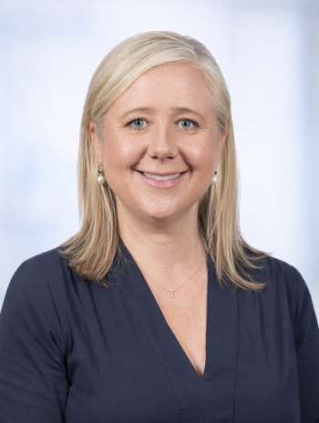  Professor Julia Maclean  PhD, MSc (Med), Deglutologist  Clinical Specialist in Speech Pathology  St George Hospital | 
Professor Julia Maclean, PhD, is the Clinical Specialist in Speech Pathology at St George Hospital, Sydney, and a Conjoint Professor at the University of New South Wales. She is internationally recognised as a leader in the clinical management and education of swallowing and airway disorders, particularly in patients recovering from complex head and neck surgery and oncology treatments, including through the Masters of Deglutology program at KU Leuven, Belgium.
Julia completed her PhD in 2010, investigating swallowing outcomes following total laryngectomy and obtained a Master of Science in Medicine in 2006, focusing on dysphagia in individuals with Chronic Airflow Limitation. Alongside her clinical and academic roles, she holds a postdoctoral research position in the Motility Unit within the Department of Gastroenterology and Hepatology, where she contributes to developing novel interventions for upper oesophageal sphincter dysfunction and late radiation fibrosis. Her current research focuses on the use of High-Resolution Pharyngeal Manometry to personalise and optimise assessment and treatment outcomes for people with swallowing disorders.
Julia was the first Allied Health professional to serve as President of the Australian and New Zealand Head and Neck Cancer Society — a role that reflects her strong commitment to multidisciplinary models of care and dedication to improving long-term outcomes for those affected by head and neck cancer treatment.


Prof Julia Maclean PhD, MSc(Med)
Clinical Specialist, Speech Pathology
Conjoint Professor
School of Clinical Medicine, UNSW Medicine & Health
St George and Sutherland Clinical Campus
Director Southern Cancer Care
Visiting Professor, Onco-Dysphagia, KU Leuven Belgium

